Textile RFID Laundry Tag Personalization Machine YPM-TLT

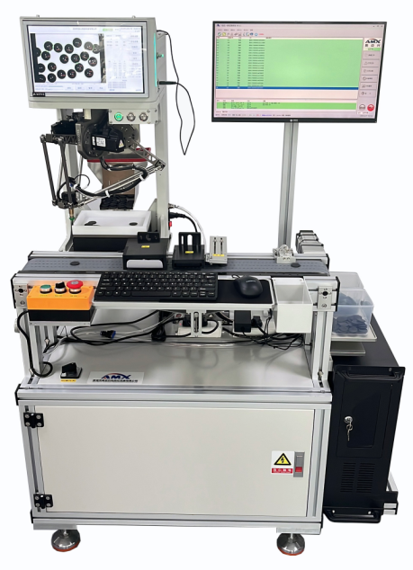
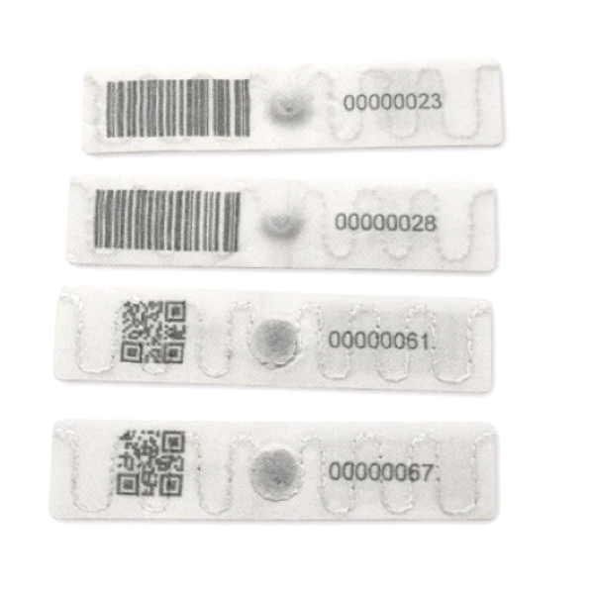

Textile RFID Laundry Tag Personalization Machine YPM-TLT is designed and made for the personalization process of various special shape textile RFID laundry tags. It can realize the functions of UHF chip (U8/ U9) data encoding, electronic performance testing and visual laser marking process in a speedy and precise way.
Textile RFID Laundry Tag Personalization Machine YPM-TLT applies the special visual material intelligent grasping module, which can realize automatic and smart robotic arm grasping and placing for special shape materials.
This machine also has the high-end visual laser marking module that can recognize the shape and pattern of materials, and then mark the precise data or logo on the chose area according to relevant settings of the equipment.
FYI, Textile RFID Laundry Tag Personalization Machine YPM-TLT is also named or known as RFID linen tags Personalization Machine or Washing Electronic Tag Personalization Machine.
Textile RFID laundry tags are also called RFID linen tags. The laundry tags are perfect for laundry tracking of garments, uniforms, bed linens, towels, and any other items that go through laundering or dry cleaning on periodic basis. The RFID laundry tag offers a cost-effective solution for industrial laundering applications and plays a vital duty in laundry management, enabling inventory visibility throughout the supply chain. The great durability of this tag even enables it to work for years and be reused in different unit garments, which greatly saves the owner’s cost.
Machine Process Flow:
RFID tags or mini card feeding-UHF chip data encoding (read UID/write data/change key)-Visual laser marking-NG rejection-Finished product counting and collection

Machine Parameters:

1). External dimensions: L1120mm*W800mm*H1500mm
2). Weight: 220 kg
3). Power Supply: AC 220V 50/60 Hz 1.5KW
4). Compressed air: ≤6.5 KG/CM²
5). Control Method: Industrial Computer + Visual Positioning System
6). Material specifications: Textile RFID Laundry Tags with U8 or U9 chips inside in different sizes.
7). Working speed: 2000-2500 pieces/hour;

Introduction of Functional Modules:
1). Material storage and feeding module: equipped with material storage and feeding functions;
2). Visual material intelligent grasping module: Through visual material position recognition, the robotic arm automatically grasps and accurately places materials;
3). Material placement and conveying module: Material conveying vacuum adsorption accurately delivers materials to the testing station;
4). Chip data processing module: suitable for LF/HF/UHF chip UID reading, data writing, change key or testing.
5). Visual laser marking module: The visual system recognizes the shape and pattern of materials, and marks accurate data information according to the parameter requirements of the equipment;
6). NG material rejection module: Remove products without chips and with unsuccessful data reading and writing;
7). Material collection module: Materials are collected and automatically counted, and collected in boxes according to the set values;

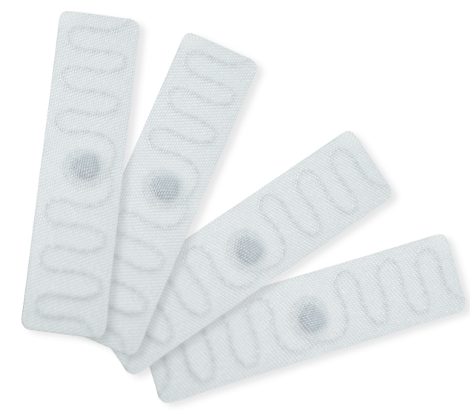

External dimensions: | L1120mm*W800mm*H1500mm | Weight: | 220kgs
Power Supply: | AC 220V 50/60 Hz 1.5KW | Compressed air: | ≤6.5 KG/CM²
Control Method: | Industrial Computer + Visual Positioning System | Material specifications: | Textile RFID Laundry Tags with U8 or U9 chips inside in different sizes.
Working speed: | 2000-2500 pieces/hour;

